The PH sensor module is a low cost, easy to use pHGauge sensor module the sensor module can be thought Arduino, MCU controller design for simulation pHMeter has the advantages of connection is simple, convenient and practical. Onboard power led,BNCInterface andPH2.0Interface. When in use, pHSensor onboardBNCInterface, onboardPH2.0Interface to connectArduinoSimulation of the controller, programmed, you can easily measure solutionspHValue.

Sensors the electrode glass electrode and a reference electrode combined with plastic shell-and-do not fill electrode, isPHMeasuring elements, used to measure the hydrogen ion activity in aqueous,PHValue.

This sensor comes with a black box with thick, Enclosing the black high quality mat, not only full protection components, and generous beauty, forwardsPHComposite electrodes user manual.

Version one:

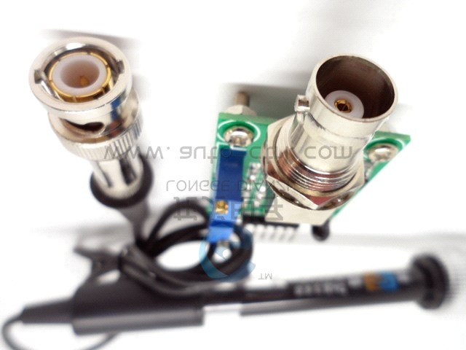

Version two:

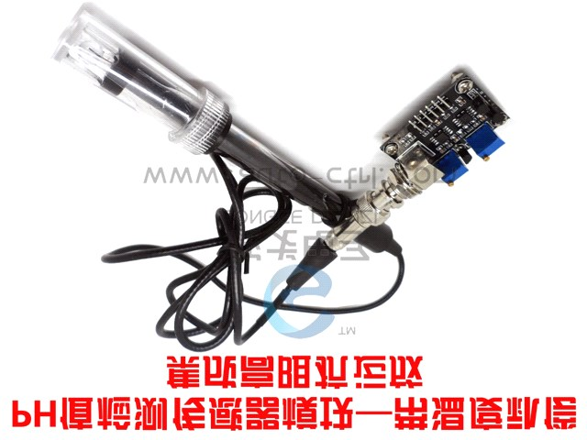

Technical specifications

* Power supply modules:+5.00V
* Module size:43mm**×**32mm**×**20mm
* Measuring range:0-14PH
* Temperature measurement:0-60 c
* Accuracy:**±**0.1pH(25℃)
* Response time:**≤**1min
* BNCInterface typepHSensor
* PH2.0Interface(3Foot patch)
* Gain adjustment potentiometer
* The power led

Use steps

Note: Please use an external switching power supply the voltage as close as possible to**+5.00V**Voltage the better, the higher the precision!

Electrodes are required before each successive use standard buffer solution for correction, to achieve better results, the ambient temperature is best**25**℃About known

**PH**Values to be reliable, but **PH**Values closer to the measured value the better. If you measure samples for acid, use **PH4.00**For electrode calibration buffer solution, if you are measuring the sample is basic, use the **PH9.18**Buffers for electrode calibration. Segmented calibration for better accuracy.

**pH**Electrode measurement **pH**A different solution, rinse is required, deionized water is recommended to clean.

**(1)**First connect the **PH**Electrodes **BNC**Connector, then **PH**Introduction to sensor modules are connected to the power supply,**PH**Sensor outputs for analog outputYou can connect **ADC**Conversion devices, such as **ARUDUINO**Analog input ports, connected after the **Arduino**After the master power supply, you can see **pH meter** Circuit board red light to brighten.

**(2)**对 **Arduino**Master programming code samples.

**(3)**将 **pH**Electrodes inserted into the **pH**Value is**7.00**Standard solution, or a direct short **BNC**Two input interface, open the **Arduino IDE**Serial port monitor, you can see the current print **pH**Value, the error does not exceed**0.3**。 Record the value of print, and then**7.00**In comparison, changes into the program difference **Offset** Office. For example, print **pH**Value is**6.88**And the difference is**0.12**, In the sample program**#define Offset 0.00**Change

**#define Offset 0.12**。

**(4)**将 **pH**Electrode insertion **pH**Value is**4.00**In the calibration fluid, wait for a minute later, adjust the gain potentiometer to make printed **pH**The fluctuations in the value**4.00** You Joh. At this point, acid calibration has been completed, you can test the acid solution **pH**Value.

Attention**:**Other solutions must clean the electrodes.

**(5)**Relying on **pH**Linear characteristic of electrodes, with the above calibration, can directly measure the alkaline solution **pH**Value, but if you want better accuracy, it is recommended that realignment. Basic calibration **pH**Value is**9.18**Standard, the same is for adjusting the gain potentiometer to make it stable**9.18**You Joh. After calibration, you can measure the alkaline solution **pH**Value of the.

Sample code

Download the sample code, open the **Arduino IDE**Serial port monitor, you can see the results.

**/\***

**# This sample codes is for testing the pH meter V1.0.**

**# Editor : YouYou**

**# Date : 2013.10.21**

**# Ver : 0.1**

**# Product: pH meter**

**# SKU : SEN0161**

**\*/**

|  |  |
| --- | --- |
| **#define SensorPin 0** | **pH meter Analog output to Arduino Analog Input 0** |
| **#define Offset 0.00** | **deviation compensate** |
| **unsigned long int avgValue; void setup()**  **{ pinMode(13,OUTPUT);**  **Serial.begin(9600);** | **Store the average value of the sensor feedback** |
| **Serial.println("Ready"); }** | **Test the serial monitor** |

**void loop()**

**{**

**int buf[10]; buffer for read analog**

**for(int i=0;i<10;i++) Get 10 sample value from the sensor for smooth the value**

**{ buf[i]=analogRead(SensorPin); delay(10); }**

**for(int i=0;i<9;i++) sort the analog from small to large**

**{ for(int j=i+1;j<10;j++)**

**{**

**if(buf[i]>buf[j])**

**{ int temp=buf[i]; buf[i]=buf[j]; buf[j]=temp;**

**}**

**}**

**} avgValue=0;**

**for(int i=2;i<8;i++) take the average value of 6 center sample avgValue+=buf[i];**

**float phValue=(float)avgValue*5.0/1024/6; convert the analog into millivolt**

**phValue=3.5*phValue+Offset; convert the millivolt into pH value**

**Serial.print(" pH:");**

**Serial.print(phValue,2); Serial.println(" "); digitalWrite(13, HIGH); delay(800);**

**digitalWrite(13, LOW);**

**}**

Maintenance and precautions

Electrodes at the time of first-time or a long time reset without using, bulb and electrode core, smothered in**3NKCL**Activation solution**8**Hour. After removing the electrode protection set to note that sensitive glass bulb in plastic protection grid does not come into contact with hard objects, for any damage and clean hair will make the electrode degradation. Measurement is complete without electrodes should be protected when on the bumpers, protective cover within a few**3.3mol/L**Potassium chloride solution, to keep the electrode bulb moist.

The Terminal part of the electrode must be kept clean and dry, and absolutely avoid short-circuit output at both ends, otherwise it will result in inaccurate measurement results or failure.

Electrode avoiding long-term immersion in distilled water cargo proteins in solution and in acidic fluoride solution, and to prevent the contact with the silicone grease.

Electrode lengthAfter the period of use, such as gradient slightly loved the Mainland, you can soak in the distal electrode**4%HF**(Hydrofluoric acid)**3-5**Second, rinse with distilled water, then soaked in a solution of potassium chloride, which renewed.

In the solution to be measured containing very sensitive bulb plug the liquid junction of domestic substances, passivation and electrode, which is sensitive to gradients reduction period, readings are not allowed. So, it should be according to the nature of the pollutant, with appropriate solutions, to complex new.

When selecting cleaning agents, such as cleaning fluid can dissolve polycarbonate resin, such as carbon tetrachloride, trichloroethylene, tetrahydrofuran, it may dissolve polycarbonate resin, coated on the sensitive glass bulb, and invalidated the electrodes, be careful about using it! Application diagram:

